**R Code for Examples in the book**

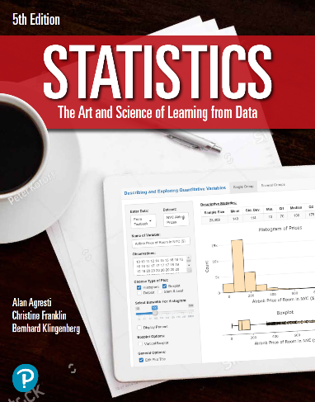

***“Statistics: The Art and Science of Learning from Data”***

**by Agresti, Franklin and Klingenberg, 5th edition**

**Chapter 2**

**Example 9: Warming Trend in NYC – Time Plot**

## Read in dataset (using updated version):

temps <- read.csv('http://www.artofstats.com/data/chapter2/central_park_yearly_temps_upto2017.csv')  
attach(temps) # so we can refer to variable names

## Basic Time Plot:

plot(x = YEAR, y = ANNUAL, type = 'l',   
 main = 'Annual Average Temperature \n in Central Park (1869-2017)',  
 ylab = 'Average Temperature')

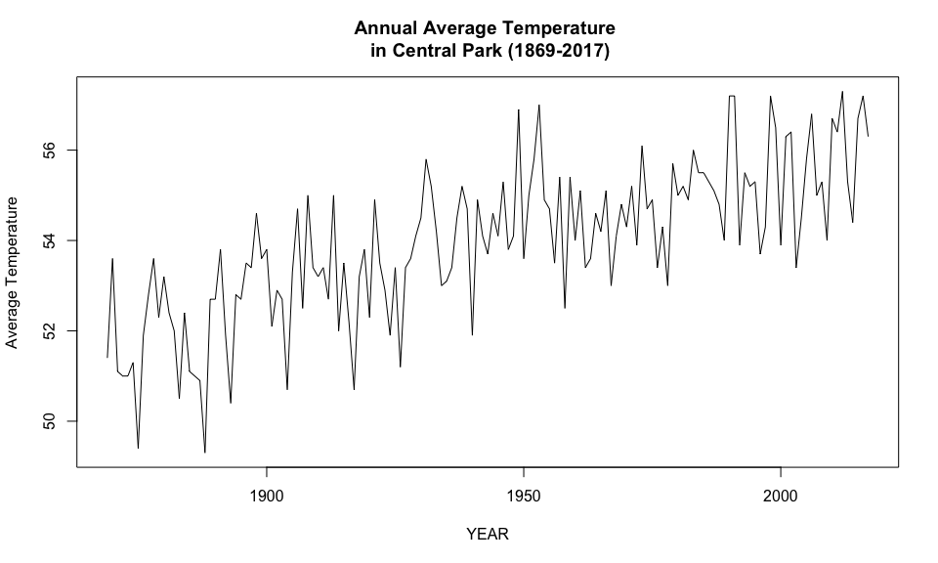

## Include Points:

plot(x = YEAR, y = ANNUAL, type = 'o', pch=19,  
 main = 'Annual Average Temperature \n in Central Park (1869-2017)',   
 ylab = 'Average Temperature')

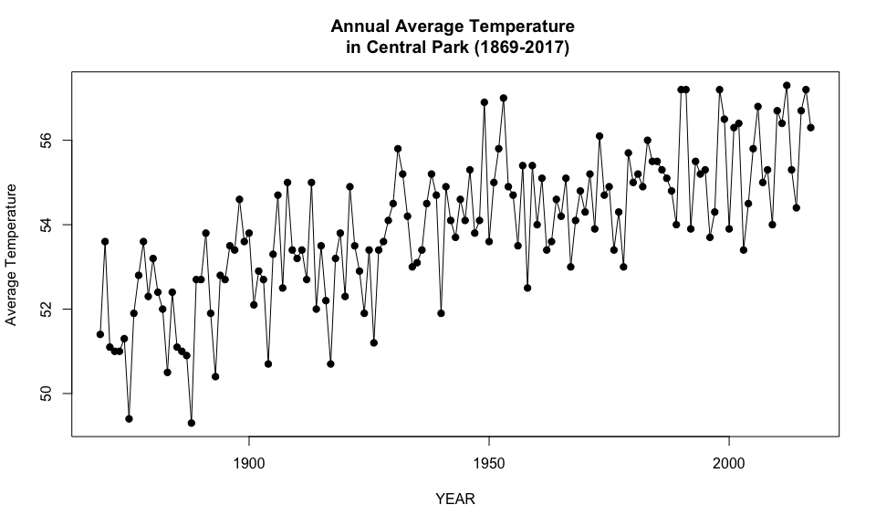

## 

## Include Smooth Trend Line:

scatter.smooth(x = YEAR, y = ANNUAL, type = 'o', pch=19,   
 lpars = list(col = 'red', lwd = 2),   
 main = 'Annual Average Temperature \n in Central Park (1869-2017)',  
 ylab = 'Average Temperature')

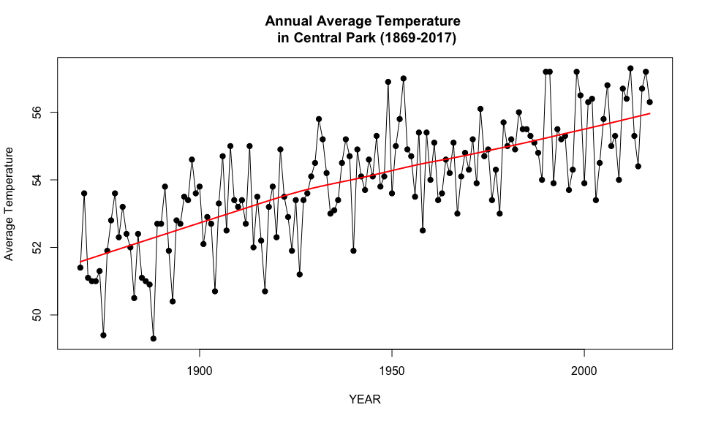

## 

## For more fine tuning, it is better to use the ggplot2 library. If you haven’t installed it already, first type: install.packages(ggplot2).

library(ggplot2)  
ggplot(data = temps, aes(x = YEAR, y = ANNUAL)) +   
 geom_point(color = 'blue') +   
 geom_line() +   
 geom_smooth(col = 'red', fill = 'orange') +  
 labs(title = 'Annual Average Temperature \n in Central Park (1869-2017)',  
 y = 'Average Temperature') +  
 scale_x_continuous(breaks = seq(min(YEAR), max(YEAR), 10)) +  
 theme_bw() +  
 theme(panel.grid.minor.x = element_blank())

